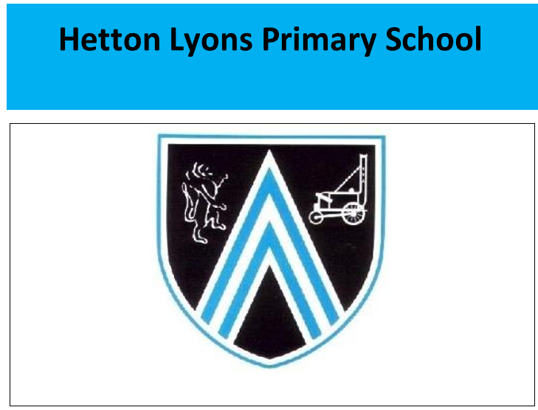

Department for Education Vision for the Primary PE and Sport Premium ALL pupils leaving primary school should be physically literate and with the knowledge, skills and motivation necessary to equip them for a healthy, active lifestyle and lifelong participation in physical activity and sport. The premium must be used to fund additional and sustainable improvements to the provision of PE and sport to encourage the development of healthy, active lifestyles. It is expected that schools will see an improvement against the following 5 key indicators:
1. The engagement of all pupils in regular physical activity - the Chief Medical Officer guidelines recommend that all children and young people aged 5 to 18 engage in at least 60 minutes of physical activity a day, of which 30 minutes should be in school.
2. The profile of PE and sport being raised across the school as a tool for whole school improvement. 3. Increased confidence, knowledge and skills of all staff in teaching PE and sport.
4. Broader experience of a range of sport and activities offered to all pupils.
5. Increased participation in competitive sport. In 2022-2023 the school will receive an estimated £19,780 to spend on school P.E. and Sport. Outlined below is how we anticipate to use this particular funding. The reader needs to be aware that there is a huge amount of additional activity which has historically taken place at Hetton Lyons, which does not come from sports premium funding.

Government focus area | What do we want to achieve? | How will we achieve it? | Predicted spend? | Spent - date | Review of Impact
1,2 | Continued access to high quality PE coaching in standard curriculum areas, including access to festivals and competitive sports as well as Active Break times. | •Continued use of REAL PE to deliver high quality teaching during curriculum sessions and to deliver focused CPD and Sports leaders CPD •Purchase of new PE resources to be used in PE activities – curriculum and after-school opportunities. | PE resources/replenishment of PE stock to deliver sessions - £1000 | Allocated = £1930  Remaining =£0 | PE curriculum provision continues to be good. Having CM as a coach has allowed staff to embed their knowledge and practise. The development of the PE curriculum ( real PE) has led to clear progressions across topics and age ranges Lesson discussions and obs form CM shows the curriculum is to a good standard throughout. The high profile of PE, combined with extra-curricular sports opportunities for all and for the more able via competitive teams ensures that quality of experience and participation in additional opportunities has continued to grow across school. Although this has been impacted with the cost of transport and bus availability.
1,3,5 | Support for pupils in lessons via increased adult ratio, particular to ensure pupils of lower ability can access lessons and make increased progress. | Continued employment of Chris Marsh qualified PE to deliver high quality teaching during curriculum sessions and to deliver focused after-school activities. •Increase in quality of delivery towards targeted children during lessons. •Increased opportunities for sport at lunchtimes and after school clubs. |  | Allocated = £8500  Remaining = £0  Chris Marsh | CM has demonstrated good PE support he has supported lessons and individuals. Pupils, particularly those of lower ability and confidence, have enjoyed support to access the lesson and individualised support and coaching.
1,3 | Strategic plan to increase PE hours for pupils and improve class teacher skills and knowledge of pupils. | •Allocate hall time to blocks of coaching each term.  •All year group and all teaching staff to work alongside high level coaches to develop long term impact.  •Coaching blocks Real PE linked to school focus and competition entry to raise skill level of pupils e.g. tennis | Booking of 5 week blocks of coaching across the year – focus of minimum of 2 sessions per year group = £5000 | Allocated = £2650  Real PE  Remaining = £0 | Real PE guidance videos and coaching criteria have been a success demo videos and guidance have been used.
3 | Commitment to CPD, in particular upskilling CM and school staff to have sustained impact across school. | •Curriculum leader to attend PE leader cluster meetings and appropriate CPD/conferences.  •PE lead and other school support staff to attend First Aid, team teach and Safeguarding training.  •Appropriate CPD for teaching staff to aid sustainability within curriculum delivery and extra-curricular activities  •Affiliation to Association for PE, to access resources, research and advice.  •Lunchtime supervisor training to meet the needs of OPAL | Supply/Cover costs to allow staff to attend training- approx. £700 See above  Release time AR and FN | Allocated = £4200  Remaining =£0 | All staff have benefitted from working with Cm and AR to develop their lessons This is vital for staff who do not regularly teach PE lessons to ensure they maintain the skills of teaching PE. By continuing to work closely the PE lead and CM , we are able to ensure that the school is aware of updates, initiatives and guidance.
2,3 | Continue to monitor and develop quality of PE coaching across the school | •Lesson cover for AR to observe lessons over year.  •Appropriate CPD delivered in house or by Real PE to improve teaching quality. | Supply/cover costs for PE lead and Senior leads to observe lessons – approx. £500 | Allocated =  Remaining = £0 | The PE lead has a high level of knowledge about the subject and additional sport. This has impact on the delivery and extra opportunities in the subject. She is able to formally and informally monitor the subject, particularly meeting CM regularly and discussing content of teaching, expectations, health and safety etc
1,2,4 | Focus to ensure pupils leaving the school continue to be 100% with 25m and to develop life skills of competent swimmers with lifesaving swimming skills. Increased opportunities for swimming competition. | . •All Y4 will continue to attend weekly lessons, 1 hour in duration, at our local leisure centre pool. Lessons delivered by qualified swimming tutors with the aim that all children achieve 25m target.  •In the summer term, Year 6 children, who have not yet attained swimming levels, will be given the option for ‘extra’ tuition. | Hiring the pool for extra swimming sessions and tutor | Allocated = £2000 Remaining = £0 | The swimming programme is successful, ensuring that children begin early enough (Y4) to overcome fear barriers they are also physically stronger to help the majority achieve national expectations.  Need to Look for possibility to book increased swimming time to to allow Year 5/ 6 children who have not yet met the standard to continue.
1,5 | Continued focus on offering increased participation in competitive intra and inter-school sports competitions | . •To continue to be part of the local Sports Academy PE cluster group and to participate in City-wide festivals and sporting competitions. •Participation in inter-school competitions, including football leagues/cups for girls/boys from Year 4, 5 & 6.  •Affiliation and participation in competitive leagues and competitions in different sports, including football, Staff cover and transport to allow access to events in curriculum time. athletics/spotsability, rugby l and hockey.  •To increase the number of after-school physical activities and therefore increase the number of participants being physically active. | Staff cover and transport to allow access to events in curriculum time. £700 League Affiliations £300 | Allocated = £1000  Remaining £0 | Competitive sport, as ever, remains a huge success story for the school, this year winning local competitions in football, athletics and hockey . The athletics team, The continued focus to offer additional competitive teams has also continued to be a great success with more than one team now being run in football, girls’ football, hockey, athletics, Sportsability
2,5 | Continue to keep the profile of PE and sport high across the school. | •Celebration and display of PE achievements, both in and out of school. •Continued use of PE noticeboard, school website and social media to celebrate activities and achievement happening in school | Supplement school team kits £0 Free kit offer girls FA  Advertising materials eg posters etc £0 | Allocated = £0 Remaining = £0 | The presentation of our teams is very good. The pure quantity of sport and number of children representing the school at a time has made monitoring the return of strips and wear and tear higher and so ‘topping’ up strips needs to continue.
1,4,5 | Increased provision of after school sports clubs across all age groups | •Get children back to a range of sporting and healthy activities post Covid  •Support families who may be struggling financially, to keep no charge after school clubs  •Offer a range of sports to children, to develop new skills and hobbies |  | Allocated = £0 Remaining = £0 | The quantity and quality of extra curriculum clubs continues to be second to none with multiple choices available each term for all year groups. Participation levels are high with nearly 70% of pupils accessing at least one club across the year..
1,4 | Development of fitness zone/mental wellbeing zone on the field as part of OPAL | •Availability of a range of fitness equipment, designed to build core strength and support sensory needs of pupils. •Particular focus on Early Year pupils, including fine and gross motor skills (climbing, pushing, balancing, gripping etc) •Accessible by children across all age ranges who may benefit from these skills and those which benefit sensory need | Purchase of a range of equipment | Allocated = £2000 Remaining = £0 | Due to the cost implication of this, the plans for this were left until later in the year but knew equipment has been ordered and craze of the week is introduced during Fridays celebration assembly. Hoops, skips , rebound balls.
1,4 | Development of ‘community’ Garden area to allow a different type of exercise and outdoor activity focus for specific children  Linked to mental health award achieved bronze | •Development of the garden area to add different sections (wildlife, planting, nature trail etc)  • Installation of better watering and composting facilities to make garden more self sufficient  •Further link with community volunteers and families to expand impact.  •Use of garden as therapeutic tool for those struggling with mental health | Purchase of equipment to allow more children to access the garden Development of areas of the garden to be more useable and accessible | Allocated = £1500 Remaining = £0 | An area has already been established for the nest. This needs further development with support from the change for life team next year. Hopefully a grant has been approved to continue to develop this are.

Appendix 1: Swimming End of year data for pupils leaving Y6 show 85% of pupils reaching age related swimming standards with 10% of pupils exceeding.

1. National curriculum outcome: Swim competently, confidently and proficiently over a distance of at least 25 metres. • Swimming at least 25 metres should be viewed as an absolute minimum. Every Year 6 child should achieve this distance, with an expectation that the majority of pupils will swim significantly further. • The swim should be continuous and completed without undue stress. The stroke or strokes used should be as strong at the end as at the start of the distance. • In completing at least 25 metres some element of this must include in deep water, defined as greater than shoulder depth. 2. National curriculum outcome: Use a range of strokes effectively. • The strokes used should be recognisable to an informed onlooker. The minimum expectation will be: - Alternative strokes: Front Crawl, Backstroke - Simultaneous strokes: Breaststroke, Butterfly 3. National curriculum outcome: Perform safe self-rescue in different water-based situations. • Emphasis should be on young people being able to safely enter and exit the water. This includes falling in and using ladders to get out of pools. • The ability to tread water and keep yourself afloat is vital for safe-self rescue, as is the ability to get back to the side. • Schools should also ensure pupils have practical experience of using their skills in outdoor swimming environments, such as the sea, canals or rivers. The Swim Safe schools programme run by Swim England and the RNLI provides practical water safety sessions for schools during the summer term and are committed to working with schools to ensure all pupils are able to access a session by 2020.

